August 2025 Best View Adventure trip :
Crater Lake / Redwood NPs

Thurs. 8/14 : meet at Medford, OR airport; drive to Crater Lake Lodge

Fri. 8/15 : Rim Drive and hikes in Crater Lake NP ; CL Lodge for the night

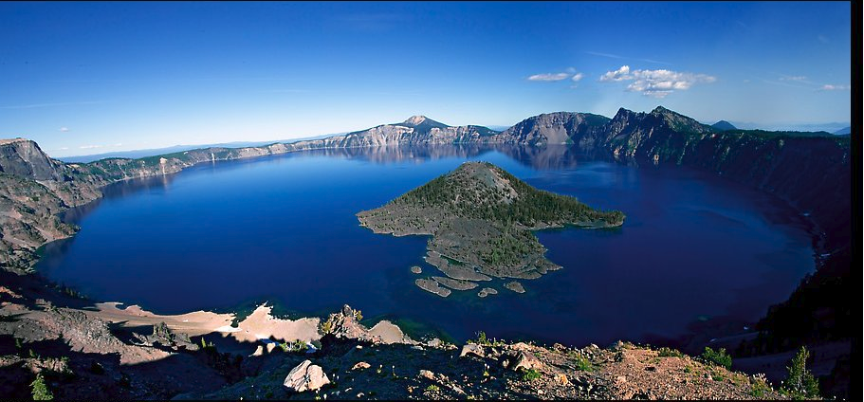

Sat. 8/16 – Boat ride out to Wizard Island ; afternoon hikes ; drive to Grant’s Pass for night

Sun. 8/17 – Tues. 8/19 : Three full days of exploring the jointly-administered Redwood NP and 3 CA State Parks ; Hiking among the groves of old-growth Redwoods, along the coastal beach bluffs, through the lush carpet of Fern Canyon, etc.
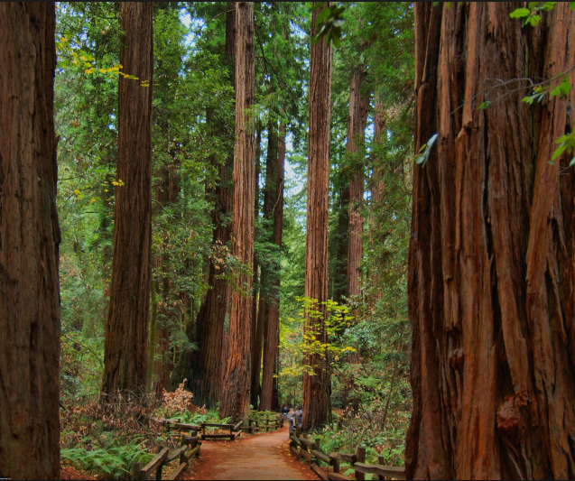
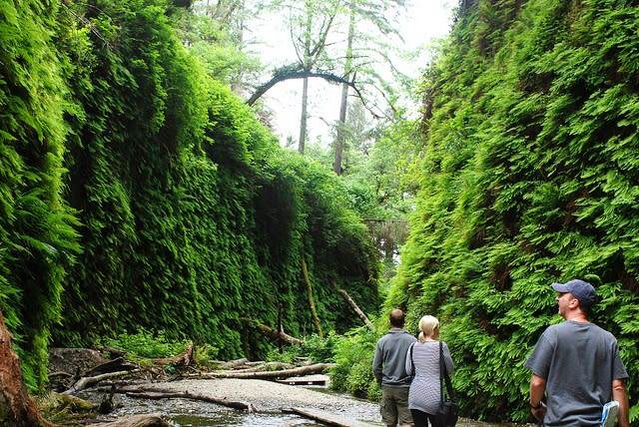
Wed. 8/20 : flights home from Medford, OR

Trip Details
What is included:
- Transportation throughout
- Personal Guided hikes
- Park entrance fees
- Lodging for 6 nights
- Breakfasts and lunches 6 days, 3 dinners
- Snacks, soft drinks, gorp, power bars, etc. in vans

Total Cost : $2595 per person (limit of 6 clients)

