**June 2025 Best View Adventure trip :**

**Zion, Bryce Canyon, and Grand Canyon NPs**

Sun. 6/15 : multiple hikes in Zion NP (your choice); Springdale for night

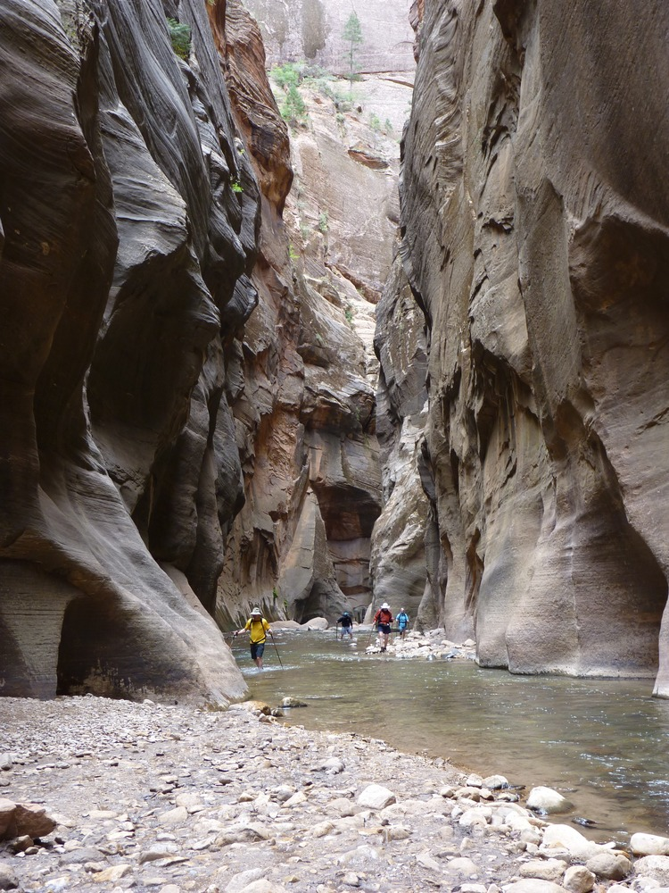

Mon. 6/16 : morning hike in Dixie National Forest, afternoon hike in Cedar Breaks National Monument; night in Bryce Village

( Look closely and you’ll see me in the middle of the rock formation)

Tues. 6/17 : day hikes in Bryce Canyon NP ; drive to Kanab for the night

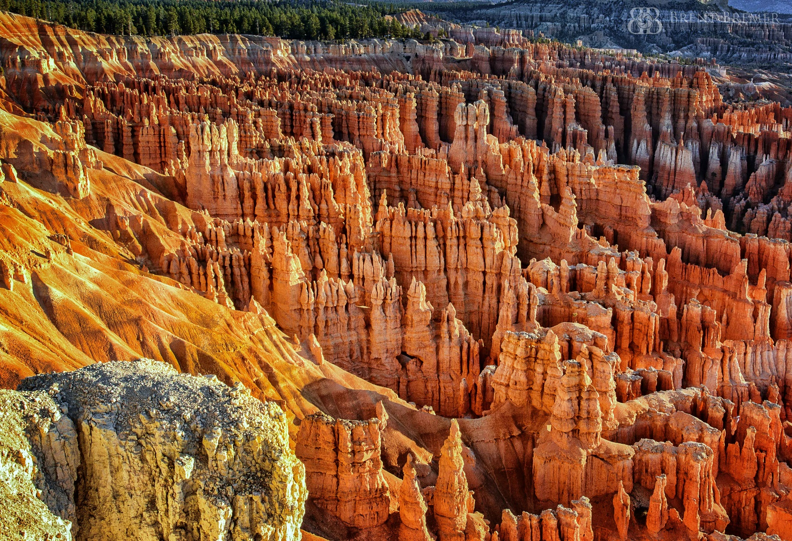

Wed. 6/18 : morning trip to Page, AZ (Horseshoe Bend, Glen Canyon dam, Antelope Canyon); drive to north rim of Grand Canyon NP for night

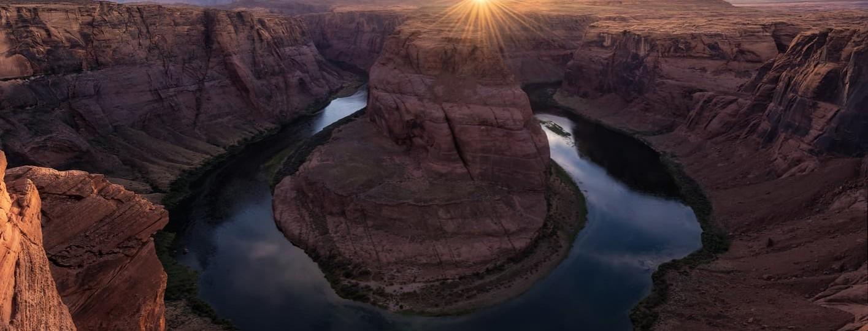

Thurs. 6/19: all day hiking rim of Grand Canyon; drinks on the patio at Grand Canyon Lodge for sunset; night in cottages there

Fri. 6/20: morning hike along GC rim; drive back through Zion NP from the east entrance; night in St. George (with celebratory dinner)

Sat. 6/21: drive back to Las Vegas for flights home

**Trip Details**

**Dates**: meet in **Las Vegas, NV** Saturday, June 14th

Sunday, 6/15 = Zion National Park

Monday, 6/16 = Cedar Breaks National Monument

Tuesday, 6/17 = Bryce Canyon National Park

Wednesday, 6/18 = Page, AZ tour

Thursday, 6/19 = Grand Canyon National Park

Friday, 6/20 = east side of Zion National Park

Saturday, 6/21 = Valley of Fire state park, return to Vegas

**What is included**:

* Transportation throughout
* Personal Guide service on hikes
* Park entrance fees
* Lodging for 7 nights
* Breakfasts and lunches all 7 days, 2 dinners
* Snacks, soft drinks, gorp, power bars, etc.

**Total Cost** : $2695 per person (limit of 8 clients)